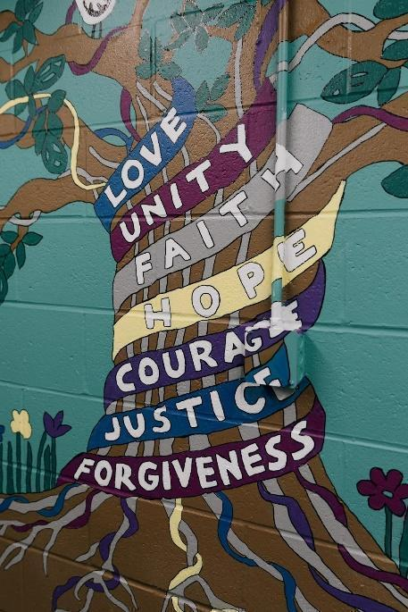
I AM &
Principle that is my strength Principle that is my struggle

I hear

I see

I taste

I touch ______

I smell

I wonder

I AM &
Repeat first Line

I seek

Love: Showing care for yourself and others.

Unity: Connecting with each other and working together.

Faith: Openness and trust in someone or something you can’t see/ trusting the positive voice inside of you.
Hope: Believing in yourself, someone or something.
Courage: Having strength to do something you are afraid of. Being honest with yourself and others.
Justice: Treating everyone fairly and equitably.
Forgiveness: Moving past something that was done wrong to you and healing from harm.
Principles of Peace definitions developed by the participants of Steven’s Circle Group at the Dever- McCormack Middle School. 2014.

I receive

I experience

I plan

I pray

I practice

I AM &
Repeat first Line

I pretend
I cry ______

I laugh
I believe
I try
I dream
I AM &
Repeat first Line

Author Date

Time Place

